I. CONTAMINATION ASSESSMENT FORM

Name: _________________________________ ____________________________ ______
(Last) (First) (MI)
ID Number: |__|__|__|__|__|__|__|__|__| Date: _____________ Time: _________

- Has the person recently had a stress test, chemotherapy, brachytherapy, pet scan, thyroid ablation or other nuclear medicine procedure?

❒ yes  no if yes, contamination screening results may be elevated.

Screening Criteria: ___________ cpm Background: ___________ cpm

Instructions:
- record measured levels of contamination for specified areas
- mark contamination findings on diagrams
- Identify contaminated wounds if present
- place an “X” in the box if no measurements were taken

Table 1: Pre-Decontamination Measurements (in cpm)

 | front | back | 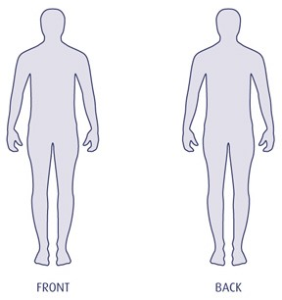
head
Breathing Zone
Torso
 | left | right
arm
Hand
leg
Sole of shoe

Table 2: post-decontamination Measurements (in cpm)

 | front | back
head
Breathing Zone
Torso
 | left | right
arm
Hand
leg
Sole of shoe

