W2C2-3 Media Buy Information

Creative can be found here: https://drive.google.com/drive/folders/1ZhIMvJRRTF_m2wqTH2KIaNQePmYRAWGo?usp=drive_link

Video Ads (as pre-roll ads and Facebook/Instagram ads)  Notes:  - All communities will be served English ads only. | Springfield Creative  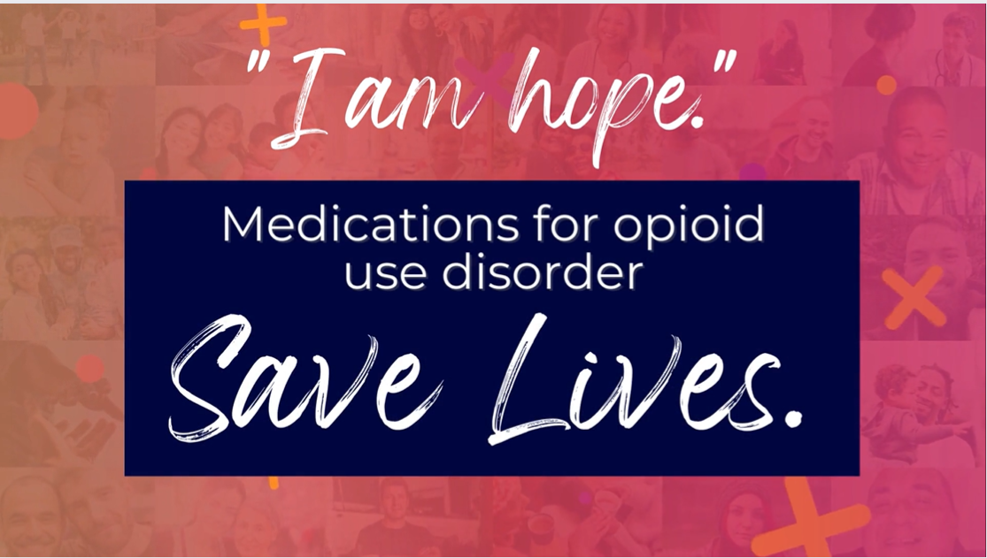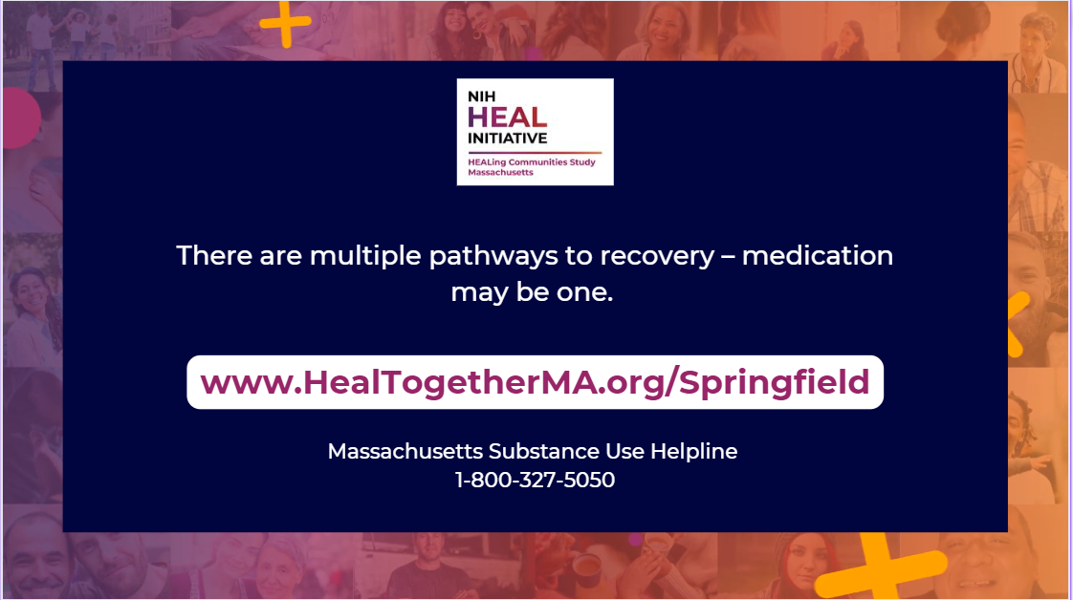  Link: www.HEALTogetherMA.org/Springfield  Facebook/Instagram Ad Text (above image). Max 125 characters including punctuation and spaces.  - There are multiple pathways to recovery – medication may be one.  Facebook/Instagram Ad Headline (right below image). Max 25 characters including punctuation and spaces.  - Medication is available  Facebook/Instagram Ad Link Description (below headline): Max 30 characters including punctuation and spaces.  - Find local resources
Pittsfield & North Adams Creative

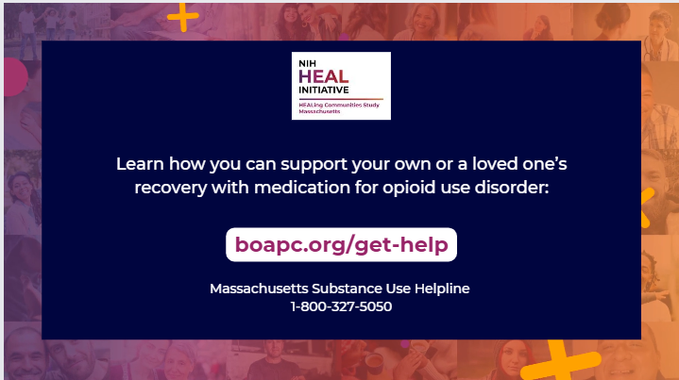

Link: https://boapc.org/get-help/

Facebook/Instagram Ad Text (above image). Max 125 characters including punctuation and spaces.
- Opioid use disorder is not a choice. It is a disease that can be treated.

Facebook/Instagram Ad Headline (right below image). Max 25 characters including punctuation and spaces.
- #NoMoreStigma

Facebook/Instagram Ad Link Description (below headline): Max 30 characters including punctuation and spaces.
Find local resources
Belchertown and Ware Creative

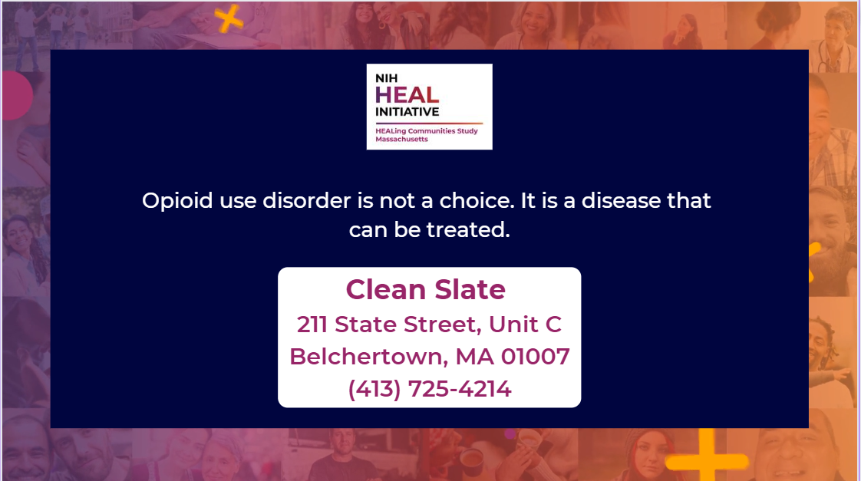

Link: https://www.cleanslatecenters.com/belchertown-massachusetts

Facebook/Instagram Ad Text (above image). Max 125 characters including punctuation and spaces.
- Opioid use disorder is not a choice. It is a disease that can be treated.

Facebook/Instagram Ad Headline (right below image). Max 25 characters including punctuation and spaces.
- #NoMoreStigma

Facebook/Instagram Ad Link Description (below headline): Max 30 characters including punctuation and spaces.
- Find local treatment
Athol, Greenfield, Montague, and Orange | Franklin-North Quabbin Creative

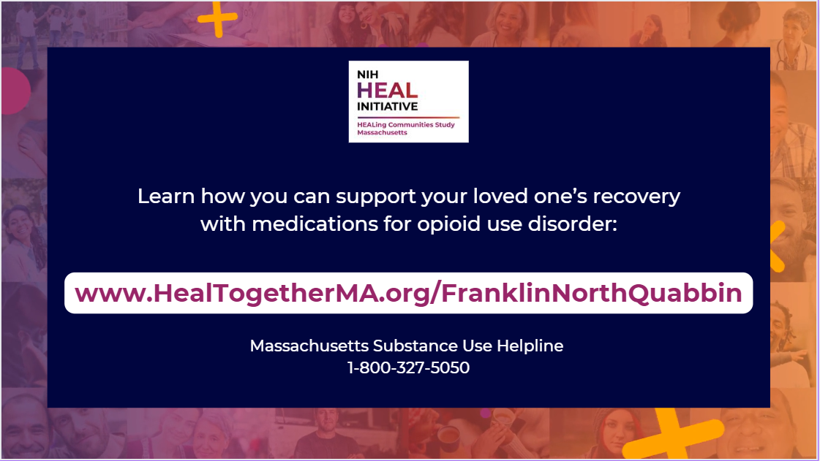

Link: http://www.healtogetherma.org/FranklinNorthQuabbin

Facebook/Instagram Ad Text (above image). Max 125 characters including punctuation and spaces.
- You can support your loved one’s recovery with medications for opioid use disorder (MOUD).

Facebook/Instagram Ad Headline (right below image). Max 25 characters including punctuation and spaces.
- Medication is available

Facebook/Instagram Ad Link Description (below headline): Max 30 characters including punctuation and spaces.
- Find local resources
Lawrence Creative

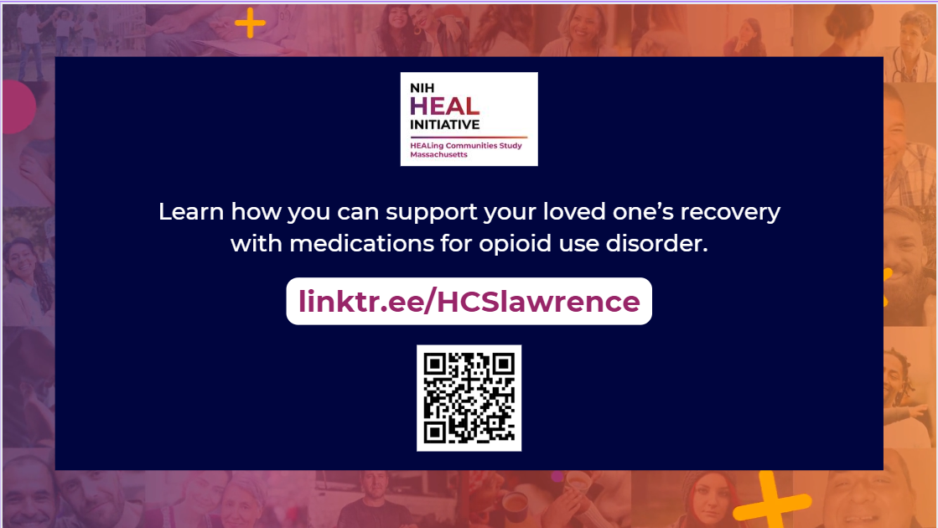

Link: https://linktr.ee/HCSlawrence

Facebook/Instagram Ad Text (above image). Max 125 characters including punctuation and spaces.
- You can support your loved one’s recovery with medications for opioid use disorder (MOUD).

Facebook/Instagram Ad Headline (right below image). Max 25 characters including punctuation and spaces.
- Medication is available

Facebook/Instagram Ad Link Description (below headline): Max 30 characters including punctuation and spaces.
Find local resources
Weymouth Creative

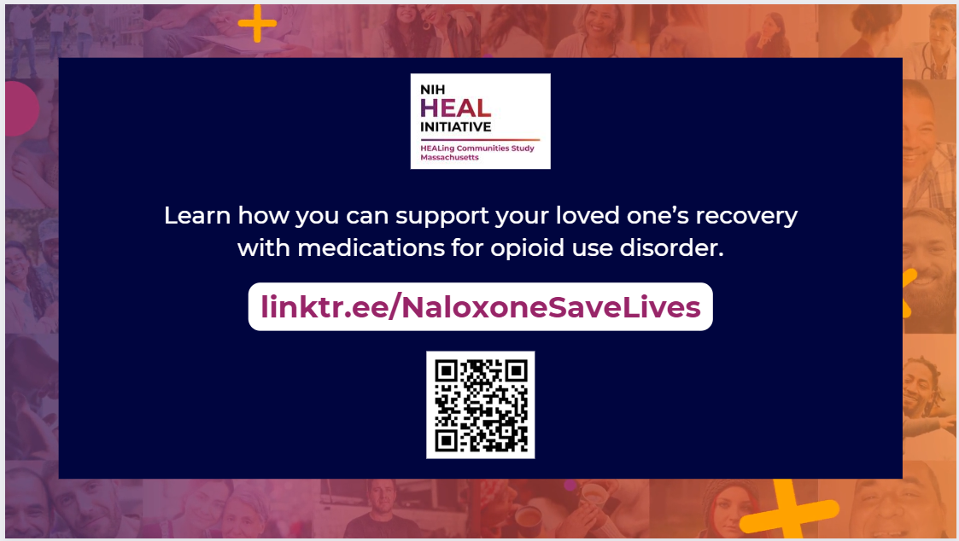

Link: https://linktr.ee/NaloxoneSaveLives

Facebook/Instagram Ad Text (above image). Max 125 characters including punctuation and spaces.
- You can support your loved one’s recovery with medications for opioid use disorder (MOUD).

Facebook/Instagram Ad Headline (right below image). Max 25 characters including punctuation and spaces.
- Medication is available

Facebook/Instagram Ad Link Description (below headline): Max 30 characters including punctuation and spaces.
- Find local resources
Berkley, Dighton, and Freetown | Bristol County Creative

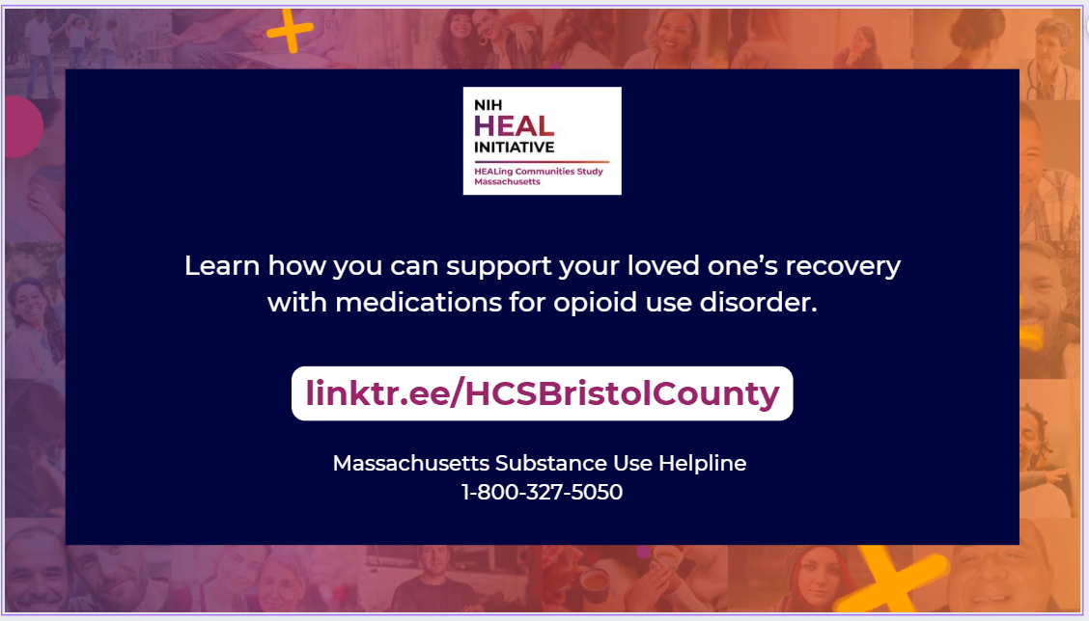

Link: https://linktr.ee/HCSBristolCounty

Facebook/Instagram Ad Text (above image). Max 125 characters including punctuation and spaces.
- You can support your loved one’s recovery with medications for opioid use disorder (MOUD).

Facebook/Instagram Ad Headline (right below image). Max 25 characters including punctuation and spaces.
- Medication is available

Facebook/Instagram Ad Link Description (below headline): Max 30 characters including punctuation and spaces.
- Find local resources

Display Ads  Notes:  - All communities will be served English ads.  - Spanish ads should be served in Springfield, Lawrence, and Franklin-North Quabbin  - Portuguese ads should be served in Weymouth. | 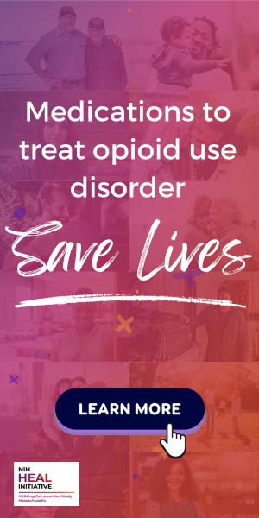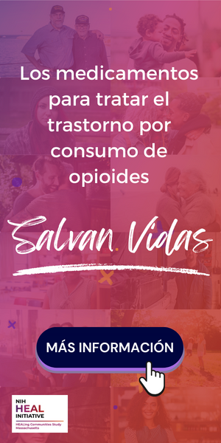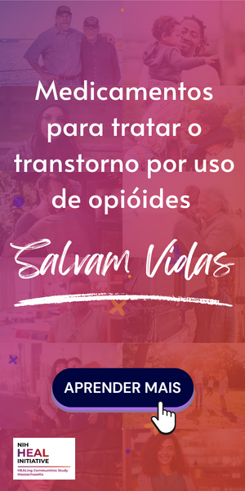  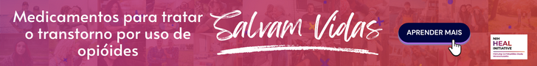  Links:  - Springfield: www.HEALTogetherMA.org/Springfield  - Pittsfield and North Adams: https://boapc.org/get-help  - Belchertown and Ware: https://www.cleanslatecenters.com/belchertown-massachusetts  - Athol, Greenfield, Montague, and Orange: http://www.healtogetherma.org/FranklinNorthQuabbin  - Lawrence: linktr.ee/HCSlawrence  - Weymouth: https://linktr.ee/NaloxoneSaveLives  - Berkley, Dighton, and Freetown: linktr.ee/HCSBristolCounty

